CYBERQUOTE PTE LTD

Sales Performance Management
Phase III

Program Design Specification
- Access Management

For: | CYBERQUOTE PTE LTD | Project Ref: | POEMSAdmin00116
Author: | Thiri Lwin | Doc Ref: | SpmPhaseIII-TS-PS-AccessManagement-1.0
Proj Mgr: | Ei Ei Thu | Version:
Date: | 21/10/2011 | Classification:
To : |  | Cc:

Document Revision History

Document Title :

Version | Revised by | Effective Date | Summary of Change | Reason for change
1.0 | Thiri Lwin | 21/10/2011 | New Document | 1.0

Table of Contents

1 Program Definition 3
1.1 System Name 3
1.2 Program Description 3
1.3 Programming Language/Version 3
1.4 Drivers Required/Version 3
2 Structure Design 3
2.1 Block Chart or Flow Chart on top level structure of the program 3
2.1.1 Presentation Layer 3
2.1.2 Web Service Layer 4
2.2 Description of each module 5
2.2.1 Presentation Layer 5
2.2.2 WebService Layer 6
2.3 Description of Stored Procedures used 7
3 Input/Output files used 7
3.1 Input/Output file format design (with Samples attached) 7
3.2 Database connections used 7
4 Error Message/Warning Message List 7
5 Program List 7
6 Acceptance Form 8

Program Definition

System Name
Sales Performance Management (hereinafter referred as SPM) system Phase III

Program Description
This is the program design specification of “Access Management” function which is defined under “Access Management” in the design specification.

Programming Language/Version
This program will be developed in C# using Visual Studio 2008 for running under ASP.net 2.0.

Drivers Required/Version
The ASP.NET AJAX 1.0 is required to support Ajax in ASP.NET environment.

Structure Design

Block Chart or Flow Chart on top level structure of the program

Presentation Layer
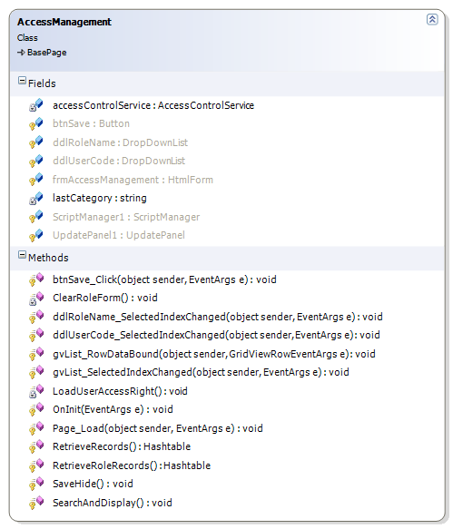
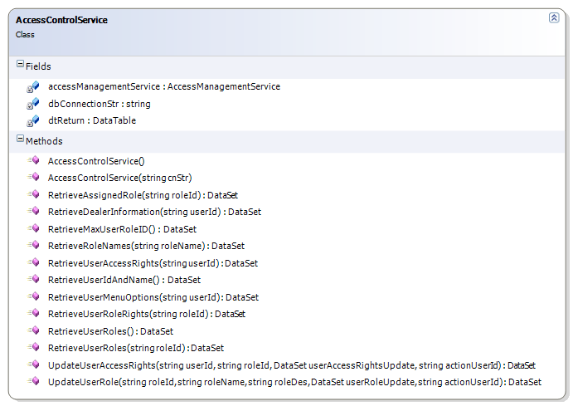

Web Service Layer

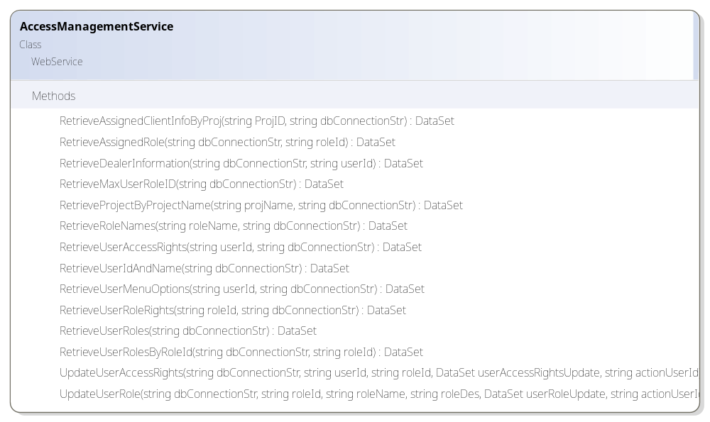
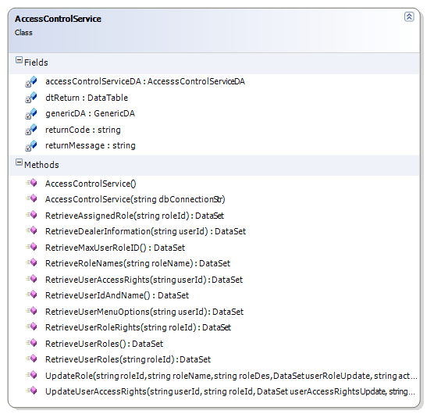
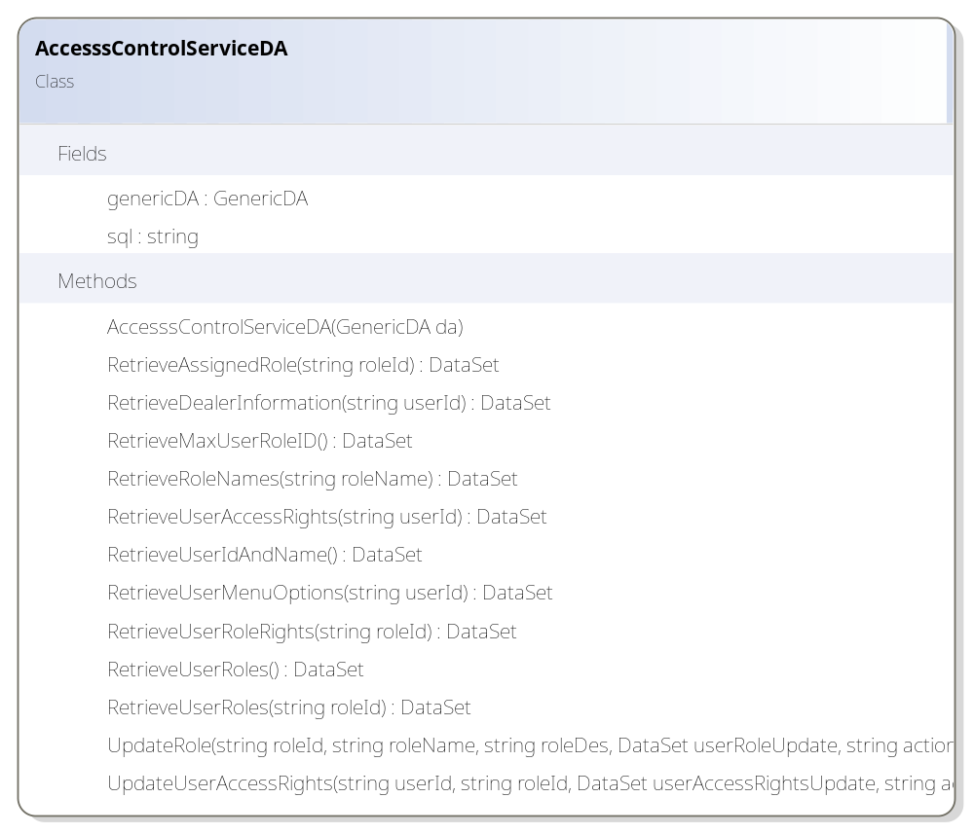

Description of each module

Presentation Layer

AccessManagement.aspx.cs
Member | Description
Fields
accessControlService | Control for accessing web service layer
Methods
OnInit | Instantiate accessControlService
Page_Load | Retrieve and construct user dropdown list  Retrieve and construct user role dropdown list
SearchAndDisplay | Turn on “Save” button if retrieved records > 0;  Turn off if retrieve records = 0;
RetrieveRecords | Retieve user access rights by calling accessControlService.RetrieveUserAccessRights() method;  Construct gridview to show existing rights in  Create, modify, view and delete  columns with functions
btnSave_Click | Save user access rights by calling accessControlService.UpdateUserAccessRights() method;
gvList_RowDataBound | Hide repeating category
ddlUserCode_SelectedIndexChanged | Retrieve user access rights immediately when user is changed in the dropdown list
ddlRowName_SelectedIndexChanged | Retrieve user role rights immediately when role is changed in the dropdown list
LoadUserAccessRight | Retrieve user access right  Call to validate user access right method with function code
RetrieveRoleRecords | Retieve user access rights by calling accessControlService. RetrieveUserRoleRights () method;  Construct gridview to show existing rights in  Create, modify, view and delete  columns with functions
SaveHide | Turn on “Save” button if retrieved records > 0;  Turn off if retrieve records = 0;
ClearRoleForm | Set Default values to role name, role code and save button

AccessControlService.cs
Member | Description
Fields
dbConnectionStr | Database connection string
accessManagementService | Reference of the access management web service
dtReturn | Return Datatable
Methods
AccessControlService | Constructor: to create access management web service instance
AccessControlService(string cnStr) | Constructor: get database connection from caller after AccessControlService() constructor
RetrieveUserAccessRights | Retrieve User access rights of all functions
RetrieveUserIdAndName | Retrieve all users with user name and login ID
RetrieveUserMenuOptions | Retrieve user’s menu options (for user main menu display)
UpdateUserAccessRights | Change user access rights
RetrieveUserRoleRights | Retrieve User role rights of all functions based on the user ID
RetrieveUserRole | Retrieve all user roles from dbo.Role table

WebService Layer

AccessManagementService.asmx.cs
Member | Description
Methods
RetrieveUserAccessRights | Retrieve User access rights of all functions
RetrieveUserIdAndName | Retrieve all users with user name and login ID
RetrieveUserMenuOptions | Retrieve user’s menu options (for user main menu display)
UpdateUserAccessRights | Change user access rights
RetrieveUserRoleRights | Retrieve role access rights of all functions based on the user ID
RetrieveUserRoles | Retrieve all user roles from dbo.Role table

AccessControlService.cs
Member | Description
Fields
AccessControlServiceDA | Data access layer for access control services
dtReturn | Return datatable
GenericDA | Generic data access layer
returnCode | Return Code  1 – Successful  -1 – Failed
returnMessage | Return message
Methods
RetrieveUserAccessRights | Retrieve User access rights of all functions
RetrieveUserIdAndName | Retrieve all users with user name and login ID
RetrieveUserMenuOptions | Retrieve user’s menu options (for user main menu display)
UpdateUserAccessRights | Change user access rights
RetrieveUserRoleRights | Retrieve role access rights of all functions based on the user ID
RetrieveUserRole | Retrieve all user roles from dbo.Role table

AccessControlServiceDA.cs
Member | Description
Fields
GenericDA | Generic data access layer
sql | Sql statements
Methods
RetrieveUserAccessRights | Retrieve User access rights of all functions
RetrieveUserIdAndName | Retrieve all users with user name and login ID
RetrieveUserMenuOptions | Retrieve user’s menu options (for user main menu display)
UpdateUserAccessRights | Change user access rights
RetrieveUserRoleRights | Retrieve role access rights of all functions based on the user ID
RetrieveUserRole | Retrieve all user roles from dbo.Role table

Description of Stored Procedures used
None

Input/Output files used
None

Input/Output file format design (with Samples attached)
N/A

Database connections used
BasePage.dbConnectionStr

Error Message/Warning Message List
Message | Cause
Error retrieving user access rights! | Failure to Retrieve user access rights
No change to save! | When user try to save but make no change on the access rights
Error saving user access rights! | When system failed to save user access rights
Problem in WebService Connection! | When system failed to call web service
System Error - Connection Problem! | When system failed to call web service
System Error – Database Problem! | When system failed to call data base
No permission to edit. Existing Record cannot be modified. | When user have no access to update on existing records.

Program List
SPMWebApp\Services
AccessControlService.cs

SPMWebApp\WebPages\AccessControl
AccessManagement.aspx
AccessManagement.aspx.cs
AccessManagement.aspx.designer.cs

SPMWebServiceApp\WebServices
AccessManagementService.asmx
AccessManagementService.asmx.cs

SPMWebServiceApp\Services
AccessControlService.cs

SPMWebServiceApp\DataAccess
AccsesssControlServiceDA.cs

Acceptance Form

Project Name : | Sales Performance Management Phase III
Document Name : | Program Design Specification - Access Management  (Doc Ref: SpmPhaseIII-TS-PS-AccessManagement-1.0)
Company Name : | CyberQuote Pte Ltd
Project Manager : | Ei Ei Thu
Designation : | Snr Consultant
Signature/Date :

